Software Requirements Specification (SRS) Template

The document in this file is an annotated outline for specifying software requirements, adapted from the IEEE Guide to Software Requirements Specifications (Std 830-1993).

Tailor this to your needs, removing explanatory comments as you go along. Where you decide to omit a section, you might keep the header, but insert a comment saying why you omit the data.

CS3911

(Team Number)

(Team Name)

Software Requirements Specification

Document

Version: (n) Date: (mm/dd/yyyy)

Table of Contents

1. Introduction
1.1 Purpose
1.2 Scope
1.3 Definitions, Acronyms, and Abbreviations
1.4 References
1.5 Overview

2. The Overall Description
2.1 Product Perspective
2.1.1 System Interfaces
2.1.2 Interfaces
2.1.3 Hardware Interfaces
2.1.4 Software Interfaces
2.1.5 Communications Interfaces
2.1.6 Memory Constraints
2.1.7 Operations
2.1.8 Site Adaptation Requirements
2.2 Product Functions
2.3 User Characteristics
2.4 Constraints
2.5 Assumptions and Dependencies
2.6 Apportioning of Requirements

3. Specific Requirements
3.1 External interfaces
3.2 Functions
3.3 Performance Requirements
3.4 Logical Database Requirements
3.5 Design Constraints
3.5.1 Standards Compliance
3.6 Software System Attributes
3.6.1 Reliability
3.6.2 Availability
3.6.3 Security
3.6.4 Maintainability
3.6.5 Portability
3.7 Organizing the Specific Requirements
3.7.1 System Mode
3.7.2 User Class
3.7.3 Objects
3.7.4 Feature
3.7.5 Stimulus
3.7.6 Response
3.7.7 Functional Hierarchy
3.8 Additional Comments

4. Change Management Process

5. Document Approvals

6. Supporting Information

1. Introduction

The following subsections provide an overview of the entire Software Requirements Specification (SRS) document.

1.1 Purpose

İş Bilir Genel Müdürlüğü a is firm which is composed of four department. These are PPB, DİB, MİDDB and YDB. The purpose of the proposed system is to manage the human resources and task control of İş Bilir Genel Müdürlüğü.
Basically system is required to keep information about

- CV’s of personnel
- Roles of the personnel
- Permissions of roles
- Orders of tasks
- Progresses of tasks
This Software Requirements Specification (SRS) document provides a complete description of all functions and constraints of Human Resource and Task Control system. HR&TC system is a single subsystem. This document does not contain the implementation of the system. These issues will be presented in Software Design and Development Document. The objectives of SRS are to provide a system overview of the HR&TC including definitions, objectives, context and major capabilities
The intended audiences of the system are;

- Users

- Admnistrator
- General Director
- Department Managers
- Personnel
- Human Resource Specialist
- Customer

- General Manager of İş Bilir Genel Müdürlüğü
- Review Team

- Group 4

- Quality Team

- Is 502 asistants

1.2 Scope

In this subsection:
- Identify the software product(s) to be produced by name
- Explain what the software product(s) will, and, if necessary, will not do
- Describe the application of the software being specified, including relevant benefits, objectives, and goals
- Be consistent with similar statements in higher-level specifications if they exist

This should be an executive-level summary. Do not enumerate the whole requirements list here.

1.3 Definitions, Acronyms, and Abbreviations.

Provide the definitions of all terms, acronyms, and abbreviations required to properly interpret the SRS. This information may be provided by reference to one or more appendices in the SRS or by reference to documents. This information may be provided by reference to an Appendix.

1.4 References

In this subsection:
(1) Provide a complete list of all documents referenced elsewhere in the SRS
(2) Identify each document by title, report number (if applicable), date, and publishing organization
- Specify the sources from which the references can be obtained.

This information can be provided by reference to an appendix or to another document. If your application uses specific protocols or RFC’s, then reference them here so designers know where to find them.

1.5 Overview

In this subsection:
- Describe what the rest of the SRS contains
- Explain how the SRS is organized

Don’t rehash the table of contents here. Point people to the parts of the document they are most concerned with. Customers/potential users care about section 2, developers care about section 3.

2. The Overall Description

Describe the general factors that affect the product and its requirements. This section does not state specific requirements. Instead, it provides a background for those requirements, which are defined in section 3, and makes them easier to understand. In a sense, this section tells the requirements in plain English for the consumption of the customer. Section3 will contain a specification written for the developers.

2.1 Product Perspective

Put the product into perspective with other related products. If the product is independent and totally self-contained, it should be so stated here. If the SRS defines a product that is a component of a larger system, as frequently occurs, then this subsection relates the requirements of the larger system to functionality of the software and identifies interfaces between that system and the software. If you are building a real system,compare its similarity and differences to other systems in the marketplace. If you are doing a research-oriented project, what related research compares to the system you are planning to build.

A block diagram showing the major components of the larger system, interconnections, and external interfaces can be helpful. This is not a design or architecture picture. It is more to provide context, especially if your system will interact with external actors. The system you are building should be shown as a black box. Let the design document present the internals.

The following subsections describe how the software operates inside various constraints.

2.1.1 System Interfaces

List each system interface and identify the functionality of the software to accomplish the system requirement and the interface description to match the system. These are external systems that you have to interact with. For instance, if you are building a business application that interfaces with the existing employee payroll system, what is the API to that system that designer’s will need to use?

2.1.2 Interfaces

Specify:
- The logical characteristics of each interface between the software product and its users.
- All the aspects of optimizing the interface with the person who must use the system

This is a description of how the system will interact with its users. Is there a GUI, a command line or some other type of interface? Are there special interface requirements? If you are designing for the general student population for instance, what is the impact of ADA (American with Disabilities Act) on your interface?

2.1.3 Hardware Interfaces

Specify the logical characteristics of each interface between the software product and the hardware components of the system. This includes configuration characteristics. It also covers such matters as what devices are to be supported, how they are to be supported and protocols. This is not a description of hardware requirements in the sense that “This program must run on a Mac with 64M of RAM”. This section is for detailing the actual hardware devices your application will interact with and control. For instance, if you are controlling X10 type home devices, what is the interface to those devices? Designers should be able to look at this and know what hardware they need to worry about in the design. Many business type applications will have no hardware interfaces. If none, just state “The system has no hardware interface requirements” If you just delete sections that are not applicable, then readers do not know if: a. this does not apply or b. you forgot to include the section in the first place.

2.1.4 Software Interfaces

Specify the use of other required software products and interfaces with other application systems. For each required software product, include:
- Name
- Mnemonic
- Specification number
- Version number
- Source

For each interface, provide:
- Discussion of the purpose of the interfacing software as related to this software product
- Definition of the interface in terms of message content and format

Here we document the APIs, versions of software that we do not have to write, but that our system has to use. For instance if your customer uses SQL Server 7 and you are required to use that, then you need to specify i.e.
2.1.4.1 Microsoft SQL Server 7. The system must use SQL Server as its database component. Communication with the DB is through ODBC connections. The system must provide SQL data table definintions to be provided to the company DBA for setup.

A key point to remember is that you do NOT want to specify software here that you think would be good to use. This is only for customer-specified systems that you have to interact with. Choosing SQL Server 7 as a DB without a customer requirement is a Design choice, not a requirement. This is a subtle but important point to writing good requirements and not over-constraining the design.

2.1.5 Communications Interfaces

Specify the various interfaces to communications such as local network protocols, etc. These are protocols you will need to directly interact with. If you happen to use web services transparently to your application then do not list it here. If you are using a custom protocol to communicate between systems, then document that protocol here so designers know what to design. If it is a standard protocol, you can reference an existing document or RFC.

2.1.6 Memory Constraints

Specify any applicable characteristics and limits on primary and secondary memory. Don’t just make up something here. If all the customer’s machines have only 128K of RAM, then your target design has got to come in under 128K so there is an actual requirement. You could also cite market research here for shrink-wrap type applications “Focus groups have determined that our target market has between 256-512M of RAM, therefore the design footprint should not exceed 256M.” If there are no memory constraints, so state.

2.1.7 Operations

Specify the normal and special operations required by the user such as:
- The various modes of operations in the user organization
- Periods of interactive operations and periods of unattended operations
- Data processing support functions
- Backup and recovery operations

(Note: This is sometimes specified as part of the User Interfaces section.) If you separate this from the UI stuff earlier, then cover business process type stuff that would impact the design. For instance, if the company brings all their systems down at midnight for data backup that might impact the design. These are all the work tasks that impact the design of an application, but which might not be located in software.

2.1.8 Site Adaptation Requirements

In this section:
- Define the requirements for any data or initialization sequences that are specific to a given site, mission, or operational mode
- Specify the site or mission-related features that should be modified to adapt the software to a particular installation

If any modifications to the customer’s work area would be required by your system, then document that here. For instance, “A 100Kw backup generator and 10000 BTU air conditioning system must be installed at the user site prior to software installation”.
This could also be software-specific like, “New data tables created for this system must be installed on the company’s existing DB server and populated prior to system activation.” Any equipment the customer would need to buy or any software setup that needs to be done so that your system will install and operate correctly should be documented here.

2.2 Product Functions

Provide a summary of the major functions that the software will perform. Sometimes the function summary that is necessary for this part can be taken directly from the section of the higher-level specification (if one exists) that allocates particular functions to the software product.

For clarity:
- The functions should be organized in a way that makes the list of functions understandable to the customer or to anyone else reading the document for the first time.
- Textual or graphic methods can be used to show the different functions and their relationships. Such a diagram is not intended to show a design of a product but simply shows the logical relationships among variables.

AH, Finally the real meat of section 2. This describes the functionality of the system in the language of the customer. What specifically does the system that will be designed have to do? Drawings are good, but remember this is a description of what the system needs to do, not how you are going to build it. (That comes in the design document).

2.3 User Characteristics

2.3.1 Administrator
The administrator will be a full time personal who operates and maintains essential parts of infrastructure of the system. The administrator should have higher education (B.A.) degree about software to operate every details of system, and should have at least average technical information and experience.

2.3.2 President

The president is the head of all the departments and founder of the company. They should be experienced in their area and should have higher education degree in their professional. The president should know general knowledge of computer usage and programs. The president should be able to create a task and analyze them.

2.3.3 Department Head

Company has many departments and each has a head that are connected to the president. Heads should have higher education degree in their professional. Heads should know general knowledge of computer usage and programs. Heads should be able to create tasks for their own personnel.

2.3.4 Personnel

Personnel do not need to have high education degree. They should have general knowledge of computer usage and programs.

2.3.5 Human Resources Expert

Human resources expert concerns with the personnel. They should have high education degree about their professional and know general knowledge of computer usage and programs.

2.4 Constraints

2.4.1 Regulatory Policies:
This project intends to develop a human resources and business management tool for an imaginary company. This company does not have any regulatory policies or constraints over the project.

2.4.2 Hardware Limitations
Project will be developed as a web application to which users can connect through a usual web browser. Servers that the project will be running are every day computers, therefore there are no hardware limitations over the project.

2.4.3 Interface to Other Applications
Work orders, holidays and vacations are expected to be viewed from Microsoft Project software. Project will be developed according to this constraint such that work orders generated within the project will be easily integrated to Microsoft Project.

2.4.4 Parallel Operation
Multiple users will be able to use the system. System will maintain data integrity constraints as multiple users are connected and making updates to system database.

2.4.5 Reliability Requirements
System will be used by a company to manage work orders and human resources functions. Employees of the company will be working according to data displayed by the system. Therefore system is expected to provide correct data to users.

2.4.6 Criticality of the Application
Work order and human resources management can highly effect companies productivity. System will automate these functionalities and employees will be working according to the system. Purpose of the system puts it in a critical position, a system crash would affect whole operations of the company.

2.4.7 Safety and Security Considirations
Project will have an authentication system to protect company information from outsiders. In more details system will allow only authorized users to view other users’ schedule and information.

2.5 Assumptions and Dependencies

List each of the factors that affect the requirements stated in the SRS. These factors are not design constraints on the software but are, rather, any changes to them that can affect the requirements in the SRS. For example, an assumption might be that a specific operating system would be available on the hardware designated for the software product. If, in fact, the operating system were not available, the SRS would then have to change accordingly.

This section is catch-all for everything else that might influence the design of the system and that did not fit in any of the categories above.

2.6 Apportioning of Requirements.

Identify requirements that may be delayed until future versions of the system. After you look at the project plan and hours available, you may realize that you just cannot get everything done. This section divides the requirements into different sections for development and delivery. Remember to check with the customer – they should prioritize the requirements and decide what does and does not get done. This can also be useful if you are using an iterative life cycle model to specify which requirements will map to which interation.

3. Specific Requirements

This section contains all the software requirements at a level of detail sufficient to enable designers to design a system to satisfy those requirements, and testers to test that the system satisfies those requirements. Throughout this section, every stated requirement should be externally perceivable by users, operators, or other external systems. These requirements should include at a minimum a description of every input (stimulus) into the system, every output (response) from the system and all functions performed by the system in response to an input or in support of an output. The following principles apply:

- Specific requirements should be stated with all the characteristics of a good SRS
- correct
- unambiguous
- complete
- consistent
- ranked for importance and/or stability
- verifiable
- modifiable
- traceable
- Specific requirements should be cross-referenced to earlier documents that relate
- All requirements should be uniquely identifiable (usually via numbering like 3.1.2.3)
- Careful attention should be given to organizing the requirements to maximize readability (Several alternative organizations are given at end of document)

Before examining specific ways of organizing the requirements it is helpful to understand the various items that comprise requirements as described in the following subclasses. This section reiterates section 2, but is for developers not the customer. The customer buys in with section 2, the designers use section 3 to design and build the actual application.

Remember this is not design. Do not require specific software packages, etc unless the customer specifically requires them. Avoid over-constraining your design. Use proper terminology:
The system shall… A required, must have feature
The system should… A desired feature, but may be deferred til later
The system may… An optional, nice-to-have feature that may never make it to implementation.

Each requirement should be uniquely identified for traceability. Usually, they are numbered 3.1, 3.1.1, 3.1.2.1 etc. Each requirement should also be testable. Avoid imprecise statements like, “The system shall be easy to use” Well no kidding, what does that mean? Avoid “motherhood and apple pie” type statements, “The system shall be developed using good software engineering practice”

Avoid examples, This is a specification, a designer should be able to read this spec and build the system without bothering the customer again. Don’t say things like, “The system shall accept configuration information such as name and address.” The designer doesn’t know if that is the only two data elements or if there are 200. List every piece of information that is required so the designers can build the right UI and data tables.

3.1 External Interfaces

This contains a detailed description of all inputs into and outputs from the software system. It complements the interface descriptions in section 2 but does not repeat information there. Remember section 2 presents information oriented to the customer/user while section 3 is oriented to the developer.

It contains both content and format as follows:

- Name of item
- Description of purpose
- Source of input or destination of output
- Valid range, accuracy and/or tolerance
- Units of measure
- Timing
- Relationships to other inputs/outputs
- Screen formats/organization
- Window formats/organization
- Data formats
- Command formats
- End messages

3.2 Functions

This document describes functional requirements of the system with use case scenerios grouped by user classes. Use cases that are common to all users are grouped together. Each use case scenario has a reference to a user interface where all required inputs are displayed. Use case scenario template is given below.

Use Case Id | Unique identifier of the use case.
Use Case Name | Name of the use case.
Actors | Primary actors related to the use case.
Goal | Main goal that is to be achieved.
Priority | Importance of the use case.
Trigger | Action that initiates this scenario.
Precondition | Conditions that mus be satisfied before the use case occurs.
Basic Path | Success path of the scenario explained step by step.
Alternate Path | Alternate situations that can occur other than the success path.
Postcondition | Conditions that will be met after use case is successfully executed.
Reference | Reference to user interface where all inputs are displayed.

3.2.1 All Users

Use cases that are common to all users of the system are explained here.
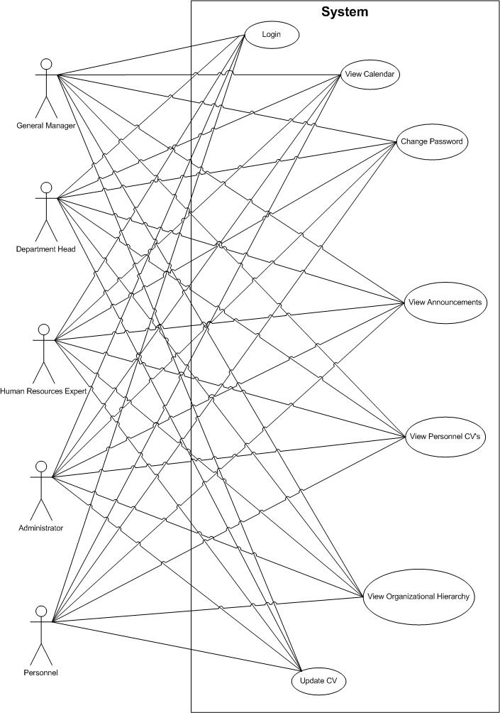

3.2.1.1 Use Case 1 – Login

Use Case Id | 1
Use Case Name | Login
Actors | General Manager, Department Manager, Personnel, Human Resources Specialist, Administrator
Goal | To login to system.
Priority
Trigger | This use case is activated when a person wants to use the system.
Precondition | User has an account registered to the system.
Basic Path | - User opens login page.  - User enters username.  - User enters password.  - User clicks login button.  - System validates user account.  - System redirects user to main page.
Alternate Path | - User enters wrong account name/password pair.  - System displays an error message indicating that account name and password is not valid.  - User enters empty account name or password.  - System displays an error message indicating the empty fields.
Postcondition | User is logged into the system and redirected to main page.
Reference

3.2.1.2 Use Case 2 – Change Password

Use Case Id | 2
Use Case Name | Change Password
Actors | General Manager, Department Manager, Personnel, Human Resources Specialist, Administrator
Goal | To change a user account’s password.
Priority
Trigger | This use case is activated when a user wants to change his password.
Precondition | User is logged into the system.
Basic Path | - User opens change password page.  - User enters username.  - User enters current password.  - User enters new password.  - User enters new password again.  - User clicks change password button.  - System ensures user entered same password twice.  - System saves new password.
Alternate Path | - User enters different new password pair.  - System displays an error message indicating that wrong new password pair.  - User leaves current password or new password field blank.  - System displays an error message indicating blank fields.
Postcondition | User account has a new password.
Reference

3.2.1.3 Use Case 3 – View Calendar

Use Case Id | 3
Use Case Name | View Calendar
Actors | General Manager, Department Manager, Personnel, Human Resources Specialist, Administrator
Goal | To view calendar.
Priority
Trigger | This use case is activated when a user wants to view calendar.
Precondition | User is logged into the system.
Basic Path | - User opens main page.  - User clicks on a date on the calendar.  - System displays view events page.
Alternate Path | - There are no events.  - System displays a message indicating that there are no events to view.
Postcondition | User viewed calendar.
Reference

3.2.1.4 Use Case 4 – View Announcements

Use Case Id | 4
Use Case Name | View Announcements
Actors | General Manager, Department Manager, Personnel, Human Resources Specialist, Administrator
Goal | To view recent announcements.
Priority
Trigger | This use case is activated when a user wants to view recent announcements.
Precondition | User is logged into the system.
Basic Path | - User opens view announcements page.  - User enters date interval.  - User clicks on search announcement button.  - System displays announcements to user.
Alternate Path | - There are no announcements.  - System displays a message indicating that there are no announcements to view.
Postcondition | User viewed recent announcements.
Reference

3.2.1.5 Use Case 5 – View Personnel CV’s

Use Case Id | 5
Use Case Name | View Personnel CV’s
Actors | General Manager, Department Manager, Personnel, Human Resources Specialist, Administrator
Goal | To view personnel CV’s
Priority
Trigger | This use case is activated when a user wants to view other personnel’s CV records.
Precondition | User is logged into the system.
Basic Path | - User opens view personnel CV’s page.  - User enters name, surname or department of the personnel.  - User selects a registered user and clicks on view personnel CV button.  - System displays selected user’s CV.
Alternate Path | - There are no CV’s registered to system.  - System displays a message indicating that there are no CV’s registered to system.
Postcondition | User viewed CV’s of other users.
Reference

3.2.1.6 Use Case 6 – View Organizational Hierarchy

Use Case Id | 6
Use Case Name | View Organizational Hierarchy
Actors | General Manager, Department Manager, Personnel, Human Resources Specialist, Administrator
Goal | To view organization hierarchy.
Priority
Trigger | This use case is activated when a user wants to view organization hierarchy.
Precondition | User is logged into the system.
Basic Path | - User enters organizational hierarchy page.  - System displays organizational hierarchy.
Alternate Path
Postcondition | User viewed organizational hierarchy.
Reference

3.2.1.7 Use Case 7 – Update CV

Use Case Id | 7
Use Case Name | Update CV
Actors | General Manager, Department Manager, Personnel, Human Resources Specialist, Administrator
Goal | To update a users CV.
Priority
Trigger | This use case is activated when a user wants to update his own CV.
Precondition | User is logged into the system.
Basic Path | - User opens Personnel CVs page.  - User enters name, surname or department of the personnel.  - User selects a registered user and clicks on view personnel CV button.  - System shows the selected user’s CV.  - User updates CV fields.  - User clicks update button.  - System saves new version of CV to database.
Alternate Path | - User leaves a mandatory field empty.  - System displays an error message indicating a mandatory field is left blank.
Postcondition | User’s CV is updated.
Reference

3.2.2 Administrator

Use cases that are special to administrator are grouped here.

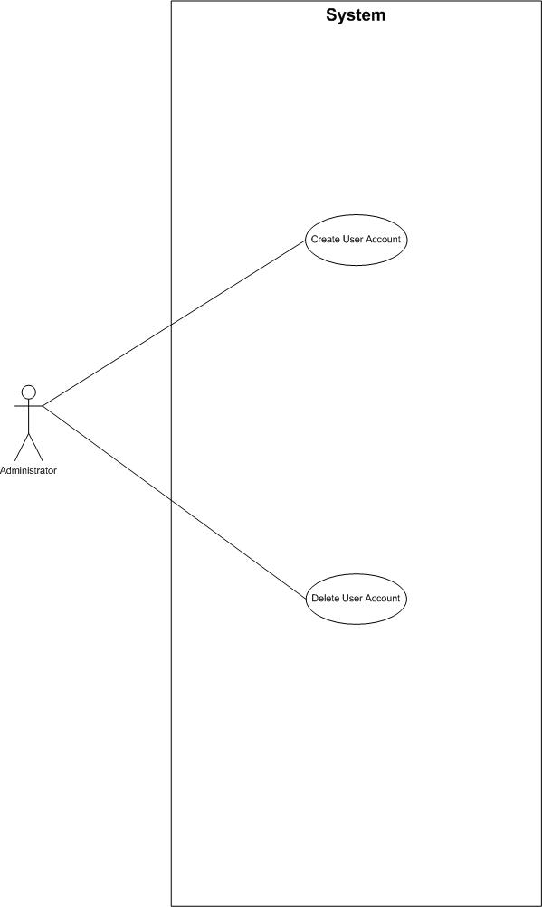

3.2.2.1 Use Case 8 – Create User Account

Use Case Id | 8
Use Case Name | Create User Account
Actors | Administrator
Goal | To create a new user account
Priority
Trigger | This use case is activated whenever a new person joins the company.
Precondition | A new person is beginning to work for the company. Administrator is logged into the system.
Basic Path | - Administrator opens create user account page.  - Administrator enters user name.  - Administrator enters password.  - Administrator selects user type.  - Administrator clicks add user button.  - System saves new user account to database.
Alternate Path | - System detects that same user account name is used before  - System displays an error message indicating existing user account name.  - Administrator changes account name.  - Administrator clicks save button.  - System saves new user account to database.  - System detects that account name or password is left blank.  - System displays an error message indicating blank fields.  - Administrator fills blank fields.  - Administrator clicks save button.  - System saves new user account to database.
Postcondition | A new user account created for new company member.
Reference

3.2.2.2 Use Case 9 – Delete User Account

Use Case Id | 9
Use Case Name | Delete User Account
Actors | Administrator
Goal | To remove an unnecessary user account from system.
Priority
Trigger | This use case is activated when a person leaves the company.
Precondition | A person leaves the company. Administrator is logged into the system.
Basic Path | - Administrator opens delete user account page.  - Administrator enters the username.  - Administrator clicks on delete button.  - System removes user account from database.
Alternate Path | - There are no user accounts to delete.  - Administrator contacts human resource specialist to mark user account to be deleted.
Postcondition | Unnecessary user account removed from system database.
Reference

3.2.3 General Manager

Use cases that are related to general manager are grouped here.

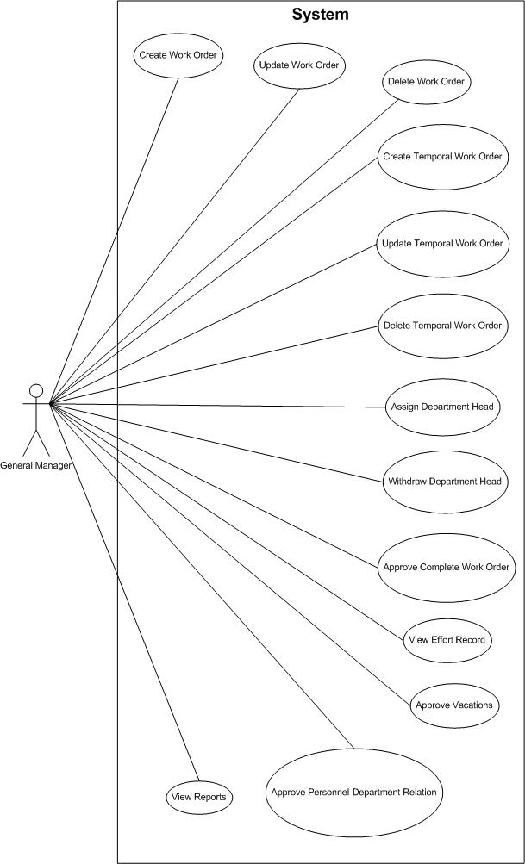

3.2.3.1 Use Case 10 – Create Work Order

Use Case Id | 10
Use Case Name | Create Word Order
Actors | General Manager
Goal | To create a work order.
Priority
Trigger | This use case is activated when general manager wants to create a work order.
Precondition | General manager is logged into system.
Basic Path | - General manager opens new from work orders page.  - General manager enters work order name.  - General manager selects user type.  - General manager selects attendant.  - General manager selects attendant role.  - General manager enters start and end date.  - General manager enters explanation.  - General clicks add button.  - System assigns a unique id to work order.  - System saves the work order to database.  - System sends an email to assigned personnel.
Alternate Path | - General manager forgets to enter mandatory fields.  - System displays an error message indicating a mandatory field is left blank.
Postcondition | A new work order is created, an email sent to assigned personnel.
Reference

3.2.3.2 Use Case 11 – Update Work Order

Use Case Id | 11
Use Case Name | Update Work Order
Actors | General Manager
Goal | To update a work order.
Priority
Trigger | This use case is activated when general manager wants to update a work order.
Precondition | General manager is logged into the system.
Basic Path | - General manager opens orders&efforts from work order page.  - General manager enters dates, department and attendant.  - General manager clicks on view work order button.  - System displays details of selected work order.  - General manager updates work order fields.  - General manger clicks update button.  - System saves new version of work order to database.
Alternate Path | - General manager forgets to enter mandatory fields.  - System displays an error message indicating a mandatory field is left blank.
Postcondition | Work order is saved to database with new values entered by general manager.
Reference

3.2.3.3 Use Case 12 – Delete Work Order

Use Case Id | 13
Use Case Name | Delete Work Order
Actors | General Manager
Goal | To delete a work order.
Priority
Trigger | This use case is activated when general manager wants to delete a work order.
Precondition | General manager is logged into the system.
Basic Path | - General manager opens orders&efforts from work order page.  - General manager enters dates, department and attendant.  - General manager clicks on view work order button.  - System displays details of selected work order.  - General manager clicks delete button.  - System removes work order from database.
Alternate Path | - There are no work orders.  - System displays a message indicating that there are no work orders to be deleted.
Postcondition | A work order is removed from system.
Reference

3.2.3.4 Use Case 14 – Create Temporal Work Order

Use Case Id | 14
Use Case Name | CreateTemporal Word Order
Actors | General Manager
Goal | To create a temporal work order.
Priority
Trigger | This use case is activated when general manager wants to create a temporal work order.
Precondition | General manager is logged into system.
Basic Path | - General manager opens create temporal work order page.  - General manager enters temporal work order title.  - General manager enters description.  - General manager enters estimated time for temporal work order.  - General manager assigns one or more personnel to temporal work order.  - General manager enters a deadline to temporal work order.  - General clicks create button.  - System assigns a unique id to temporal work order.  - System saves the temporal work order to database.  - System sends an email to assigned personnel.
Alternate Path | - General manager forgets to enter mandatory fields.  - System displays an error message indicating a mandatory field is left blank.
Postcondition | A new temporal work order is created, an email sent to assigned personnel.
Reference

3.2.3.5 Use Case 15 – Update Temporal Work Order

Use Case Id | 15
Use Case Name | Update Temporal Work Order
Actors | General Manager
Goal | To update a temporal work order.
Priority
Trigger | This use case is activated when general manager wants to update a temporal work order.
Precondition | General manager is logged into the system.
Basic Path | - General manager opens update temporal work order page.  - System displays open temporal work orders.  - General manager selects a temporal work order.  - System displays details of selected temporal work order.  - General manager updates temporal work order fields.  - General manger clicks save button.  - System saves new version of temporal work order to database.
Alternate Path | - General manager forgets to enter mandatory fields.  - System displays an error message indicating a mandatory field is left blank.
Postcondition | Temporal work order is saved to database with new values entered by general manager.
Reference

3.2.3.6 Use Case 16 – Delete Temporal Work Order

Use Case Id | 16
Use Case Name | Delete Temporal Work Order
Actors | General Manager
Goal | To delete a temporal work order.
Priority
Trigger | This use case is activated when general manager wants to delete a temporal work order.
Precondition | General manager is logged into the system.
Basic Path | - General manager opens delete temporal work order page.  - System displays list of open temporal work orders.  - General manager selects a temporal work order.  - General manager clicks delete button.  - System removes temporal work order from database.
Alternate Path | - There are no temporal work orders.  - System displays a message indicating that there are no temporal work orders to be deleted.
Postcondition | A temporal work order is removed from system.
Reference

3.2.3.7 Use Case 17 – Assign Department Manager

Use Case Id | 17
Use Case Name | Assign Department Manager
Actors | General Manager
Goal | To assign a personnel as a department manager.
Priority
Trigger | This use case is activated when general manager wants to assign a personnel as a department manager.
Precondition | General manager is logged into the system.
Basic Path | - General manager opens assign department manager page.  - General manager enters name and surname.  - General manager clicks on search button.  - System displays personnel.  - General manager enters user role.  - General manager clicks add button.  - System saves department manager to database.
Alternate Path | - All departments have a head.  - System displays a message indicating that all departments already have a head.  - There are no personnel to assign.  - System displays a message indicating that there are no personnel that can be assigned as a department manager.
Postcondition | A person is assigned as a department manager.
Reference

3.2.3.8 Use Case 18 – Withdraw Department Manager

Use Case Id | 18
Use Case Name | Withdraw Department Manager
Actors | General Manager
Goal | To withdraw a personnel from being a department manager.
Priority
Trigger | This use case is activated when department manager decides to withdraw a personnel from being a department manager.
Precondition | General manager is logged into the system.
Basic Path | - General manager opens assign department manager page.  - General manager enters name and surname.  - General manager clicks on search button.  - System displays personnel.  - General manager clicks delete button.  - System deletes department manager assignment from database.
Alternate Path | - There are no assigned department managers.  - System displays a message indicating that there are no department managers to withdraw.
Postcondition | A department manager is withdrew from his position.
Reference

3.2.3.9 Use Case 19 – Approve Complete Work Order

Use Case Id | 19
Use Case Name | Approve Complete Work Order
Actors | General Manager
Goal | To approve a completed work order.
Priority
Trigger | This use case is activated when a work order is completed.
Precondition | General manager is logged into system.
Basic Path | - General manager opens orders&effort from work orders page.  - General manager enters dates, department and attendant.  - General manager clicks on view work order button.  - System displays details of selected work order.  - General manager clicks on view effort record button.  - System displays view effort record page.  - General manager selects the order.  - General manager clicks approve button.  - System saves work order as approved.
Alternate Path | - There are no completed work orders.  - System displays a message indicating that there are no work orders to approve.  - General manager disapproves a work order.  - General manager selects a work order.  - General manager clicks disapprove button.  - System saves work order as disapproved.
Postcondition | A work order is approved or disapproved.
Reference

3.2.3.10 Use Case 20 – View Effort Record

Use Case Id | 20
Use Case Name | View Effort Record
Actors | General manager
Goal | To view effort record of a person.
Priority
Trigger | This use case is activated when general manager wants to view effort record of a person.
Precondition | General manager is logged into system.
Basic Path | - General manager opens orders&effort from work orders page.  - General manager enters dates, department and attendant.  - General manager clicks on view work order button.  - System displays details of selected work order.  - General manager clicks on view effort record button.  - System displays view effort record page.
Alternate Path | - There are no work orders.  - System displays a message indicating that there are no workorders.
Postcondition | General manager viewed effort record of a person.
Reference

3.2.3.11 Use Case 21 – View Gant Chart

Use Case Id | 21
Use Case Name | View gant chart
Actors | General Manager
Goal | View gant chart of the department
Priority
Trigger | This use case is activated whenever department manager wants to view effort record of the personnel
Precondition | General manager logins to the system
Basic Path | - General manager opens orders&effort from work orders page.  - General manager enters dates,department and attendant.  - General manager clicks on view work order button.  - System displays details of selected work order.  - General manager clicks on view effort record button.  - System displays view effort record page.  - General manager clicks on view gant chart button.  - System displays gant chart page.
Alternate Path | - There are no work orders.  - System displays a message indicating that there are no workorders.
Postcondition | General manager viewed gant chart
Reference

3.2.3.12 Use Case 22 – Approve Leaves

Use Case Id | 22
Use Case Name | Approve Leaves
Actors | General Manager
Goal | To approve vacations of department managers.
Priority
Trigger | This use case is activated when human resources expert creates a vacation for a department manager.
Precondition | General manager is logged into the system.
Basic Path | - General manager opens leaves page.  - General manager selects department.  - General manager clicks on search button.  - System displays vacations waiting to be approved.  - General manager selects a vacation.  - General manager clicks approve button.  - System saves vacation as approved.
Alternate Path | - There are no vacations to approve.  - System displays a message indicating there are no vacations waiting to be approved.  - General manager disapproves a vacation.  - General manager selects a vacation.  - General manager clicks disapprove button.  - System saves vacation as disapproved.
Postcondition | A vacation is approved or disapproved.
Reference

3.2.3.13 Use Case 23 – Approve Personnel-Department Relation

Use Case Id | 23
Use Case Name | Approve Personnel-Department Relation
Actors | General Manager
Goal | To approve a personnel department relation.
Priority
Trigger | This use case is activated when human resources expert creates assigns a person to a department.
Precondition | General manager is logged into the system.
Basic Path | - General manager opens personnel page.  - System displays list of pending personnel-department relations.  - General manager selects a personnel-department relation.  - General manager clicks approve button.  - System saves personnel-department relation as approved.
Alternate Path | - There are no pending personnel-department relations.  - System displays a message indicating that there are no personnel-department relations waiting to be approved.  - General manager does not approve personnel-department relation.  - General manager selects a personnel-department relation.  - General manager clicks disapprove button.  - System saves personnel-department relation as disapproved.
Postcondition | A personnel-department relation is approved or disapproved.
Reference

3.2.3.14 Use Case 24 – View Reports

Use Case Id | 24
Use Case Name | View Reports
Actors | General manager
Goal | To view company statistics as reports.
Priority
Trigger | This use case is activated when general manager wants to view company reports.
Precondition | General manager is logged into the system.
Basic Path | - General manager opens reports page.  - General manager selects a report type.  - General manager selects one of a personnel, a department or whole company  - General manager clicks show report button.  - System calculates statistical values.  - System displays selected report to general manager.
Alternate Path
Postcondition | General manager viewed company statistics.
Reference

3.2.4 Department Manager

Use case scenarios special to department managers are grouped here.
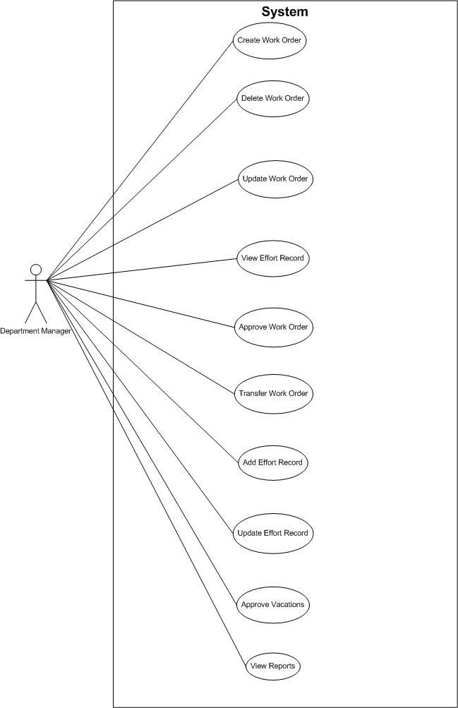

3.2.4.1 Use Case 25 – Create Work Order

Use Case Id | 25
Use Case Name | Create work order
Actors | Department Manager
Goal | To create a new work order for personnel
Priority
Trigger | This use case is activated whenever department manager wants to create work order
Precondition | Department manager logins to the system
Basic Path | - Department manager opens new from work orders page.  - Department manager enters work order name.  - Department manager selects user type.  - Department manager selects attendant.  - Department manager selects attendant role.  - Department manager enters start and end date.  - Department manager enters explanation.  - Department manager clicks add button.  - System assigns a unique id to work order.  - System saves the work order to database.  - System sends an email to assigned personnel.
Alternate Path | - System detects that start and end date is past  - System displays error message indicating date is past.  - Department manager changes the dates.  - Department manager clicks add button.  - System saves new work order to database.  - General manager forgets to enter mandatory fields.  System displays an error message indicating a mandatory field is left blank.
Postcondition | A new work order is created, an email sent to assigned personnel.
Reference

3.2.4.2 Use Case 26 – Update Work Order

Use Case Id | 26
Use Case Name | Update work order
Actors | Department Manager
Goal | Update work order for personnel
Priority
Trigger | This use case is activated whenever department manager wants to update work order
Precondition | Department manager logins to the system
Basic Path | - Department manager opens orders&efforts from work order page.  - Department manager enters dates, department and attendant.  - Department manager clicks on view work order button.  - System displays details of selected work order.  - Department manager updates work order fields.  - Department manger clicks update button.  - System saves new version of work order to database.
Alternate Path | - Department manager forgets to enter mandatory fields.  - System displays an error message indicating a mandatory field is left blank.
Postcondition | Work order is saved to database with new values entered by general manager.
Reference

3.2.4.3 Use Case 27 – Delete Work Order

Use Case Id | 27
Use Case Name | Delete work order
Actors | Department Manager
Goal | Delete work order of personnel
Priority
Trigger | This use case is activated whenever department manager wants to delete work order
Precondition | Department manager logins to the system
Basic Path | - Department manager opens orders&efforts from work order page.  - Department manager enters dates, department and attendant.  - Department manager clicks on view work order button.  - System displays details of selected work order.  - Department manager clicks delete button.  - System removes work order from database.
Alternate Path | - There are no work orders.  - System displays a message indicating that there are no work orders to be deleted.
Postcondition | A work order is removed from system.
Reference

3.2.4.4 Use Case 28 – View Effort Record

Use Case Id | 28
Use Case Name | View effort record
Actors | Department Manager
Goal | View effort record of the personnel
Priority
Trigger | This use case is activated whenever department manager wants to view effort record of the personnel
Precondition | Department manager logins to the system
Basic Path | - Department manager opens orders&effort from work orders page.  - Department manager enters dates, department and attendant.  - Department manager clicks on view work order button.  - System displays details of selected work order.  - Department manager clicks on view effort record button.  - System displays view effort record page.
Alternate Path | - There are no work orders.  a. System displays a message indicating that there are no workorders.
Postcondition | Department manager viewed effort record
Reference

3.2.4.5 Use Case 29 – View Gant Chart

Use Case Id | 29
Use Case Name | View gant chart
Actors | Department Manager
Goal | View gant chart of the department
Priority
Trigger | This use case is activated whenever department manager wants to view gant chart of the department.
Precondition | Department manager logins to the system
Basic Path | - Department manager opens orders&effort from work orders page.  - Department manager enters dates and attendant.  - Department manager clicks on view work order button.  - System displays details work orders.  - Department manager selects a work order.  - Department manager clicks on view effort record button.  - System displays view effort record page.  - Department manager clicks on view gant chart button.  - System displays gant chart page.
Alternate Path | 1. There are no work orders.  a. System displays a message indicating that there are no workorders.
Postcondition | Department manager viewed gant chart
Reference

3.2.4.6 Use Case 30 – Approve Work Order

Use Case Id | 30
Use Case Name | Approve work order
Actors | Department Manager
Goal | Approve the status of the work order’s completeness
Priority
Trigger | This use case is activated whenever department manager wants to approve the work order
Precondition | Department manager logins to the system
Basic Path | - Department manager opens orders&effort from work orders page.  - Department manager enters dates, department and attendant.  - Department manager clicks on view work order button.  - System displays details of selected work order.  - Department manager clicks on view effort record button.  - System displays view effort record page.  - Department manager selects the order.  - Department manager clicks approve button.  - System saves work order as approved.
Alternate Path | - There are no completed work orders.  - System displays message indicating that there are no work orders to approve.  - Department manager disapproves work order.  - Department manager selects a work order.  - Department manager clicks disapprove button.  - System saves work order as disapproved.
Postcondition | 1. Other attendants’’ of the work order will be approved.
Reference

3.2.4.7 Use Case 31 – Transfer Work Order

Use Case Id | 31
Use Case Name | Transfer work order
Actors | Department Manager
Goal | Transfer the work orders from general director to the personnel
Priority
Trigger | This use case is activated whenever department manager wants to transfer the work order to personnel
Precondition | Department manager logins to the system
Basic Path | - Department manager clicks own orders.  - Department manager selects the order that will be transferred.  - Department manager selects the attendant that the order will be transferred.  - Department manager clicks the transfer button.  - Work order will be transferred
Alternate Path
Postcondition | Other attendants’’ of the work order will be approved.
Reference

3.2.4.8 Use Case 32 – Add Effort Record

Use Case Id | 32
Use Case Name | Add effort record
Actors | Department Manager
Goal | Add effort record of the work order
Priority
Trigger | This use case is activated whenever department manager wants to add effort record for his work order.
Precondition | Department manager logins to the system
Basic Path | - Department manager clicks own orders.  - Department manager selects the order ..  - Department manager enters effort record.  - Department manager clicks the add button.  - Effort record will be added to database.
Alternate Path
Postcondition
Reference

3.2.4.9 Use Case 33 – Update Effort Record

Use Case Id | 33
Use Case Name | Update effort record
Actors | Department Manager
Goal | Update effort record of the work order
Priority
Trigger | This use case is activated whenever department manager wants to update effort record for his work order.
Precondition | Department manager logins to the system
Basic Path | - Department manager clicks own orders.  - Department manager selects the order ..  - Department manager enters effort record.  - Department manager clicks the update button.  - Effort record will be updated in the database.
Alternate Path | - User can only update current date’s effort record otherwise system will give error.
Postcondition
Reference

3.2.4.10 Use Case 34 – Approve Leaves

Use Case Id | 34
Use Case Name | Approve leaves
Actors | Department Manager
Goal | To approve leaves of department heads.
Priority
Trigger | This use case is activated when human resources specialist creates a leave for personnel.
Precondition | Department manager is logged into the system.
Basic Path | - Department manager opens leaves page.  - Department l manager selects department.  - Department manager clicks on search button.  - System displays vacations waiting to be approved.  - Department manager selects a vacation.  - Department manager clicks approve button.  - System saves vacation as approved.
Alternate Path | 1. There are no vacations to approve.  a. System displays a message indicating there are no vacations waiting to be approved.  2. Department manager disapproves a vacation.  b. Department manager selects a vacation.  c. Department manager clicks disapprove button.  d. System saves vacation as disapproved.
Postcondition | A vacation is approved or disapproved.
Reference

3.2.4.11 Use Case 35 – View Reports

Use Case Id | 35
Use Case Name | View Reports
Actors | Department manager
Goal | To view company statistics as reports.
Priority
Trigger | This use case is activated when department manager wants to view company reports.
Precondition | Department manager is logged into the system.
Basic Path | - Department manager opens reports page.  - Department manager selects a report type.  - Department manager selects one of a personnel, a department or whole company.  - Department manager clicks view report button.  - System calculates statistical values.  - System displays selected report to department manager.
Alternate Path
Postcondition | Department manager viewed company statistics.
Reference

3.2.5 Personnel

Use case scenarios that will be used by personnel users are grouped here.
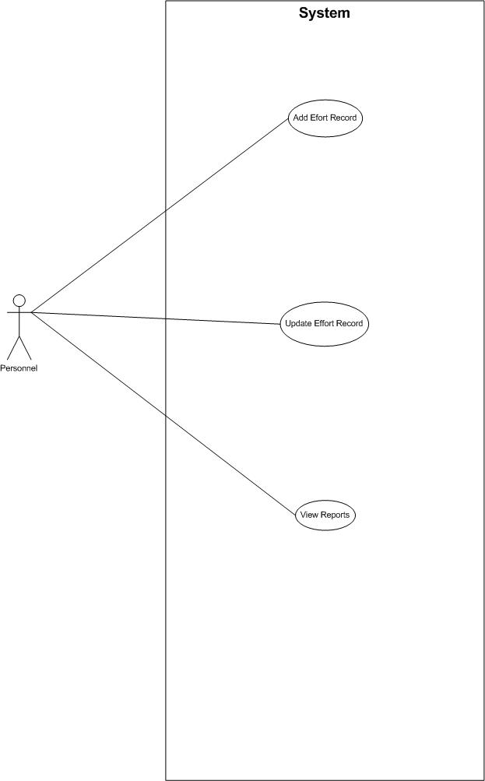

3.2.5.1 Use Case 36 – Add Effort Record

Use Case Id | 36
Use Case Name | Add effort record
Actors | Personnel
Goal | Add effort record of the work order
Priority
Trigger | This use case is activated whenever department manager wants to add effort record for his work order.
Precondition | Personnel logins to the system
Basic Path | - Personnel clicks work orders and efforts.  - Personnel enters date interval.  - Personnel clicks on view work orders button.  - System displays work orders.  - Personnel select the order.  - Personnel clicks on enter effort record.  - System dislays effort record page.  - Personnel enters completion percentage.  - Personnel clicks the add button.  - Effort record will be added to database.
Alternate Path | - General manager forgets to enter mandatory fields.  - System displays an error message indicating a mandatory field is left blank.
Postcondition | Effort record is added.
Reference

3.2.5.2 Use Case 37 – Update Effort Record

Use Case Id | 37
Use Case Name | Update effort record
Actors | Personnel
Goal | Update effort record of the work order
Priority
Trigger | This use case is activated whenever personnel want to update effort record for his work order.
Precondition | Personnel login to the system
Basic Path | - Personnel clicks work orders and efforts.  - Personnel enters date interval.  - Personnel clicks on view work orders button.  - System displays work orders.  - Personnel select the order.  - Personnel enters view effort records button.  - System displays view effort records page.  - Personnel update fields.  - Personnel click the update button.  - Effort record will be updated in the database.
Alternate Path | User can only update current date’s effort record otherwise system will give error.
Postcondition | Effort record is updated.
Reference

3.2.5.3 Use Case 38 – View Reports

Use Case Id | 38
Use Case Name | View Reports
Actors | Personnel
Goal | To view own performance reports.
Priority
Trigger | This use case is activated when personnel wants to view own performance reports.
Precondition | Personnel logs into the system.
Basic Path | - Personnel opens reports page.  - System displays reports.
Alternate Path
Postcondition | Personnel viewed own performance reports.
Reference

3.2.6 Human Resources Specialist

Use cases that will be executed by human resources specialist are grouped here.

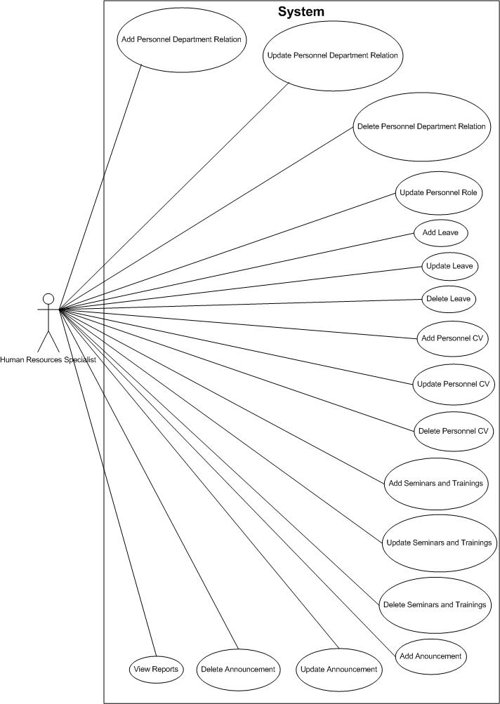

3.2.6.1 Use Case 39 – Add Personnel Department Relation

Use Case Id | 39
Use Case Name | Add personnel department relation
Actors | HR
Goal | To add personnel to a department.
Priority
Trigger | This use case is activated when HR wants to add personnel to a department.
Precondition | HR logs into the system.
Basic Path | - HR selects department page.  - HR enters ssn, name and surname of the personnel.  - HR selects the department.  - HR selects the role.  - HR selects the user type.  - HR clicks on the add button.  - System saves personnel-department relation to database.
Alternate Path | If personnel allready works in a department, system gives error indicating match exists.
Postcondition | HR added personnel to one of the departments.
Reference

3.2.6.2 Use Case 40 – Update Personnel Department Relation

Use Case Id | 40
Use Case Name | Update personnel department relation
Actors | HR
Goal | To update personnel department relation.
Priority
Trigger | This use case is activated when HR wants to update personnel department relation.
Precondition | HR logs into the system.
Basic Path | - HR selects department page.  - HR enters name and surname of the personnel.  - HR selects the department.  - HR clicks on search button.  - System displays the user’s info.  - HR update fields.  - HR clicks on the update button.  - System updates personnel-department relation in database.
Alternate Path
Postcondition | HR updated personnel department relation.
Reference

3.2.6.3 Use Case 41 – Delete Personnel Department Relation

Use Case Id | 41
Use Case Name | Delete personnel from department relation
Actors | HR
Goal | To delete a personnel department relation.
Priority
Trigger | This use case is activated when HR wants to delete a personnel department relation.
Precondition | HR logs into the system.
Basic Path | - HR selects department page.  - HR enters name and surname of the personnel.  - HR selects the department.  - HR clicks on search button.  - System displays the user’s info.  - HR clicks on the delete button.  - System deletes personnel-department relation from database.
Alternate Path
Postcondition | HR deleted a personnel department relation from database.
Reference

3.2.6.4 Use Case 42 – Update Personnel Role

Use Case Id | 42
Use Case Name | Update personnel role
Actors | HR
Goal | To update personnel role.
Priority
Trigger | This use case is activated when HR wants to update personnel’s role.
Precondition | HR logs into the system.
Basic Path | - HR selects roles.  - HR enters name, surname of the personnel.  - HR selects department.  - HR clicks on search button.  - System displays personel’s info.  - HR selects the role.  - HR clicks on the update button.  - System updates personnel’s role in database.
Alternate Path
Postcondition | HR updated personnel’s role.
Reference

3.2.6.5 Use Case 43 – Add Leave

Use Case Id | 43
Use Case Name | Add leave
Actors | HR
Goal | To add personnel leave.
Priority
Trigger | This use case is activated when HR wants to update personnel’s leave.
Precondition | HR logs into the system.
Basic Path | - HR selects leaves.  - HR enters name, surname of the personnel.  - HR selects department.  - HR clicks on search button.  - System displays personel’s info.  - HR enters start and end date of the leave.  - HR enters the type of the leave.  - HR clicks on add future leaves button.  - System adds leave to the database.
Alternate Path | - HR forgets to enter mandatory fields.  a.System displays an error message indicating a mandatory field is left blank.
Postcondition | - HR added personnel leave.  - Personnel’s leave approvement is sent to related department’s manager.
Reference

3.2.6.6 Use Case 44 – Update Leave

Use Case Id | 44
Use Case Name | Update leave
Actors | HR
Goal | To update personnel leave.
Priority
Trigger | This use case is activated when HR wants to update personnel’s leave.
Precondition | HR logs into the system.
Basic Path | - HR selects leaves.  - HR enters name, surname of the personnel.  - HR selects department.  - HR clicks on search button.  - System displays personel’s info.  - HR clicks on view leaves button.  - System displays leaves.  - HR updates necessary fields.  - HR clicks on update button.  - System updates leave from the database.
Alternate Path | If selected leaves’ date is past, system gives error indicating past date cannot be deleted.
Postcondition | HR update personnel leave.
Reference

3.2.6.7 Use Case 45 – Delete Leave

Use Case Id | 45
Use Case Name | Delete leave
Actors | HR
Goal | To delete personnel leave.
Priority
Trigger | This use case is activated when HR wants to delete personnel’s leave.
Precondition | HR logs into the system.
Basic Path | - HR selects leaves.  - HR enters name, surname of the personnel.  - HR selects department.  - HR clicks on search button.  - System displays personel’s info.  - HR clicks on view leaves button.  - System displays leaves.  - HR clicks on delete button.  - System deletes leave from the database.
Alternate Path | If selected leaves’ date is past, system gives error indicating past date cannot be deleted.
Postcondition | HR deleted personnel leave.
Reference

3.2.6.8 Use Case 46 – Add Personnel CV

Use Case Id | 46
Use Case Name | Add personnel CV
Actors | HR
Goal | To add personnel cv.
Priority
Trigger | This use case is activated when HR wants to add personnel cv.
Precondition | HR logs into the system.
Basic Path | - HR selects personnel CVs.  - HR enters personnel name, surname, SSN, user type, role.  - HR enters personnel information, education information, work experience, certificates.  - HR clicks on add button.  - System adds personnel CV to database.
Alternate Path | If name, surname, SSN, user type and role is left blank system gives error indicating it is blank.
Postcondition | HR added personnel CV.
Reference

3.2.6.9 Use Case 47 – Update Personnel CV

Use Case Id | 47
Use Case Name | Update personnel CV
Actors | HR
Goal | To update personnel cv.
Priority
Trigger | This use case is activated when HR wants to update personnel cv.
Precondition | HR logs into the system.
Basic Path | - HR selects personnel CVs.  - HR enters personnel name, surname, department.  - HR clicks on the search button.  - HR enters personnel name, surname, SSN, user type or role.  - HR enters personnel information, education information, work experience or certificates.  - HR clicks on update button.  - System updates personnel CV in database.
Alternate Path | If name, surname, SSN, user type and role is left blank system gives error indicating it is blank.
Postcondition | HR updated personnel CV.
Reference

3.2.6.10 Use Case 48 – Delete Personnel CV

Use Case Id | 48
Use Case Name | Delete personnel CV
Actors | HR
Goal | To delete personnel cv.
Priority
Trigger | This use case is activated when HR wants to delete personnel cv.
Precondition | HR logs into the system.
Basic Path | - HR selects personnel CVs.  - HR enters personnel name, surname, department.  - HR clicks on the search button.  - HR clicks on delete button.  - System deletes personnel CV from database.
Alternate Path
Postcondition | HR deleted personnel CV.
Reference

3.2.6.11 Use Case 49 – Add Seminars and Trainings

Use Case Id | 49
Use Case Name | Add seminars and trainings
Actors | HR
Goal | To add the seminars and trainings of the personnel and the department managers.
Priority
Trigger | This use case is activated when HR wants to add seminars and trainings.
Precondition | HR logs into the system.
Basic Path | - HR selects seminars and trainings.  - HR enters personnel name, surname, department, activity name, activity date and time and explanation.  - HR clicks on the add seminars and trainings button.  - System adds seminars and trainings to database.
Alternate Path
Postcondition | - HR added seminars and training.  - Personnel will see the activity in their calendar.
Reference

3.2.6.12 Use Case 50 – Update Seminars and Trainings

Use Case Id | 51
Use Case Name | Update seminars and trainings
Actors | HR
Goal | To update the seminars and trainings of the personnel and the department managers.
Priority
Trigger | This use case is activated when HR wants to update seminars and trainings.
Precondition | HR logs into the system.
Basic Path | - HR selects seminars and trainings.  - HR enters personnel name, surname, department, activity name or activity date.  - HR clicks on the search button.  - HR selects activity.  - HR updates necessary fields.  - HR clicks on the update button.  - System updates seminars and trainings in database.
Alternate Path | If activity’s date has past, system gives error indicating it cannot be updated.
Postcondition | - HR updated seminars and training.  - Personnel will see the activity in their calendar.
Reference

3.2.6.13 Use Case 52 – Delete Seminars and Trainings

Use Case Id | 52
Use Case Name | Delete seminars and trainings
Actors | HR
Goal | To delete the seminars and trainings of the personnel and the department managers.
Priority
Trigger | This use case is activated when HR wants to delete seminars and trainings.
Precondition | HR logs into the system.
Basic Path | - HR selects seminars and trainings.  - HR enters personnel name, surname, department, activity name or activity date.  - HR clicks on the search button.  - HR selects activity.  - HR clicks on the delete button.  - System updates seminars and trainings in database.
Alternate Path | If activity’s date has past, system gives error indicating it cannot be deleted.
Postcondition | - HR deleted seminars and training.  - Activity will be deleted from the calendar.
Reference

3.2.6.14 Use Case 53 – Add Anouncement

Use Case Id | 53
Use Case Name | Add announcement
Actors | HR
Goal | To add announcement.
Priority
Trigger | This use case is activated when HR wants to add announcement.
Precondition | HR logs into the system.
Basic Path | - HR selects announcements.  - HR enters announcement title, date, end date, status and note.  - HR clicks on the enter new announcement button.  - System adds announcement to database.
Alternate Path | - If the date is past date, system gives error.
Postcondition | Announcement will be seen in pages of the personnel
Reference

3.2.6.15 Use Case 54 – Update Announcement

Use Case Id | 54
Use Case Name | Update announcement
Actors | HR
Goal | To update announcement.
Priority
Trigger | This use case is activated when HR wants to add announcement.
Precondition | HR logs into the system.
Basic Path | - HR selects announcements.  - HR enters date interval.  - HR clicks on search announcement button.  - System displays announcements.  - HR selects announcement.  - HR updates necessary fields.  - HR clicks on the update button.  - System updates announcement in database.
Alternate Path | - If the date is past date, system gives error.
Postcondition | Announcement will be seen in pages of the personnel
Reference

3.2.6.16 Use Case 55 – Delete Announcement

Use Case Id | 55
Use Case Name | Delete announcement
Actors | HR
Goal | To delete announcement.
Priority
Trigger | This use case is activated when HR wants to delete announcement.
Precondition | HR logs into the system.
Basic Path | - HR selects announcements.  - HR enters date interval.  - HR clicks on search announcement button.  - System displays announcements.  - HR selects announcement.  - HR clicks on the delete button.  - System deletes announcement from database.
Alternate Path
Postcondition | Announcement will be deleted
Reference

3.2.6.17 Use Case 56 – View Reports

Use Case Id | 56
Use Case Name | View reports
Actors | HR
Goal | To view all kinds of reports.
Priority
Trigger | This use case is activated when HR wants to view reports.
Precondition | HR logs into the system.
Basic Path | - HR selects reports.  - HR clicks on the view button.
Alternate Path
Postcondition
Reference

3.2.6.18 Use Case 57 – Add event

Use Case Id | 57
Use Case Name | Add event
Actors | HR
Goal | To add event to a date.
Priority
Trigger | This use case is activated when HR wants to add event to a date
Precondition | HR logs into the system.
Basic Path | - HR right clicks on a date.  - System displays calendar options page.  - HR clicks on an option.  - System directs to related page.
Alternate Path
Postcondition | HR added an event with the selected date.
Reference

3.3 Performance Requirements

3.3.1 Multiple Users
System shall be able to serve upto 30 users simultaneously without degrading system performance which will be decribed in following titles of this section. After 30 users a new servers shall be added to the system for each 30 users, this way performance requirements will be met.

3.3.2 Response Time

Performance values are given assuming that system server does not have any other network load and it is dedicated to this project.

- Users shall be able to login less than 5 seconds on a full system load.
- Users shall be able to view any web page served by this project less than 10 seconds.
- The system shall be able to prepare and display any report less than 15 seconds.

3.4 Logical Database Requirements

ER diagram of the sytem can be found in the Appendix.

3.5 Design Constraints

The design of the System shall be according to IEEE Standard 1016-1998 Recommended Practice for Software Design Descriptions.

3.5.1. Reporting Format

The system shall generate reports in a standard format which consist of header and body parts. Report should include report date and time.

3.6 Software System Attributes

3.6.1 Reliability

3.6.1.1 System's meantime between failures will be one month.

3.6.2 Availability

      - System will be available to user access for 24 hours.

      - In case of any system crash, previous state of the system will be accessible i.e rollback mechanism.

Security

System will be ‘username’ and ‘password’ authenticated.

Current user types will lead to usage of functions in the system

Login session will be 10 minutes.

Maintainability

      - All new classes, functions and other software elements used will be clearly defined and documented.

      - System will be maintaned by the administrator.

Portability

      - System will work on all operating systems which runs apache web server.

      - Database can be dunped to all relational databases.

